A6-How to set A6 works as AP
Product line: Wireless Question category: Function configurations

Q: Why we need to set A6 works as AP mode?
A: Sometimes we just have a broadband router but we want wireless devices can get on line wirelessly, AP mode can help you realize that.

The topology should be as below:
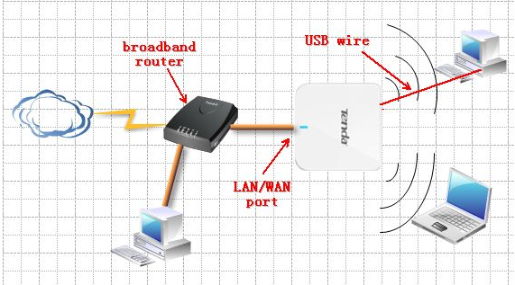
The steps are as below:
- Make sure that you can access to the internet when you just connect your computer to the uplink router or modem directly by a cable;
- Login to the homepage of the A6;
- Click Quick Setup->Wireless AP Mode as the picture below and then click Next:
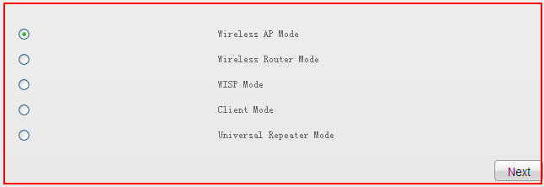

- Then you will be in the following page, please do the settings as the picture, you can change SSID, it’s your wireless network’s name,
Security Key is your wireless password; it should be at least 8 characters.
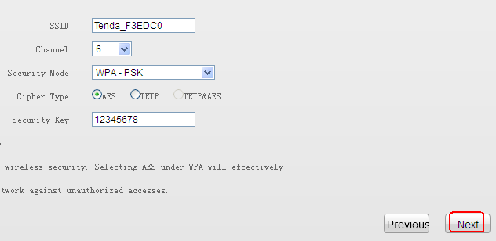

- Click Finish to save the settings.
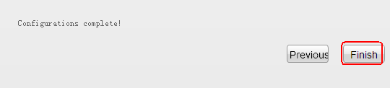

6. Connect A6 to your uplink router or modem as the topology, then use your wireless devices to search its SSID and connect to it.

